Chapter 17, Solution 50.

c_{n} = 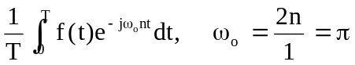

= 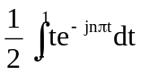

Using integration by parts,

u = t and du = dt

dv = e^{–jnπt}dt which leads to v = –[1/(2jnπ)]e^{–jnπt}

c_{n} = 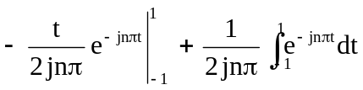

= 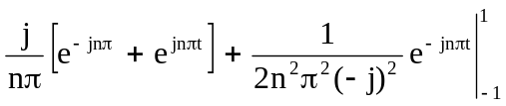

= [j/(nπ)]cos(nπ) + [1/(2n²π²)](e^{–jnπ} – e^{jnπ})

c_{n} = 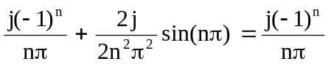

Thus
f(t) =   